**Check AD Replication:--**

1. Log in into server
2. Open Command Prompt.
3. Type repadmin /replsummary

This Command shows AD Replication as follows.

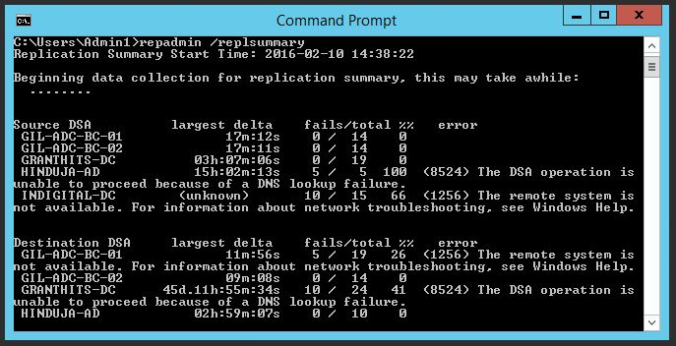

**Checking Events:-**

1. Open Event Viewer (Click the **Start**🡪**Control Panel** 🡪**Administrative Tools** 🡪**Event Viewer** )
2. In the event viewer window on Left side click on System and check events.

